Prototyping and Usability Testing
Your Project Toolkit

About This Toolkit
How to Use
To get started with this toolkit:
- Click File > Make a copy… in the upper-left corner.
- Give the file a title that includes your first and last name.
- Click OK.
- The toolkit is now saved to your Google Drive account, where you’ll be able to edit it.
Your Project Challenge
In this project, you’ll create a prototype, conduct usability testing, and synthesize and communicate your findings.

This toolkit provides the resources to help you:
- Create a usability test plan.
- Synthesize and report your test results.
- Outline a presentation for communicating your findings.


Planning Your Usability Test
Use the template below to prepare your test plan.

PROJECT NAME: Travelers “R” U
Usability Test Plan | PREPARED BY: Wei Da Chen | 7/29/20
Description | I am using my prototype to test if the user can efficiently navigate through my mobile app to access the live chat feature in the Account Page.
Goals | - The user is able to access the app.  - The user takes a few seconds to look through the placement of the buttons at the bottom of the screen.  - The user` opens the Account Page and can quickly identify & press the Live Chat Icon.
Schedule and Environment | - When: @3pm  - Where: Facebook Messenger Video Call
Equipment | Mobile Phone (iPhone/Android)
Recruiting Method | Recruitment through my network and snowball recruiting.
Users | (Include information about the users in your test group; aim for 3–5 participants.)  - My test group consists of 5 participants ranging from 20-year-olds to 60-year-olds.  - 2 Asians ages 20  - 1 Asian age 47  - 1 Caucasian age 21  - 1 Hispanic age 20
Link to Prototype | https://www.figma.com/proto/Hz86MT8qFHsRPRQO2aZJa8/Unit-5-Prototyping-and-Testing?node-id=12%3A42&scaling=scale-down
USABILITY TEST SCRIPT
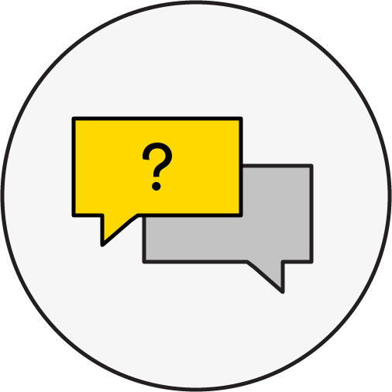 | INTRODUCTION  - Hi, my name is Wei and I am a UX consultant for an enterprise that specializes in providing design and technical solutions to travel and transportation agencies. I will be walking you through this session today.  - You probably have a good idea of why we asked you here, but let me go over it again briefly. We’re asking people to try to navigate our mobile app prototype that we’re working on so we can see whether it works as intended. This session will last about half an hour at most.  - “This is a prototype and might not be fully functional.”  - The first thing that I want to make clear right away is that we’re testing the app, not you. You can’t do anything wrong here.  - “Is it OK to record this test?”  OPENING QUESTIONS  - First, do you have any familiarity with the type of app this is?  - Now, roughly how many hours a week altogether would you spend using your phone, including playing games and checking emails, at work, or at home?  - What type of primary device do you own?  FIRST IMPRESSIONS (Ask users to describe what they see without clicking on your prototype.)  - First, I’m going to ask you to look at this homepage of the app and tell me what you think of it: what strikes you about it, whose app do you think it is, what you can do here, and what it’s for.  - Is there anything about the general layout of the app that stands out to you?  - Is there anything you would like to tap/click on?  TASK SCENARIOS  - It’s a beautiful Saturday afternoon in Brooklyn, New York, but you are unsure of whether it’ll rain later on in the day. Open the Traveler’s “R” Us’ app and check the weather forecast.  - You’re now home after a long day of work and you think you’ve been working hard for the past couple of weeks so you need a break. You’re scrolling through Traveler’s “R” Us’ app for discounted vacation bundles but you’re encountering technical difficulties. Try navigating to the live chat feature.  FINAL THOUGHTS (Ask users to share any final thoughts about your product or their user experience.)  - How did the navigation experience on this app compare to the navigation experience on other travel apps?  - If there’s one thing we definitely need to work on, what would it be?  - Is there anything you expected to be able to do but couldn’t?  - Thanks, that was very helpful. If there’s anyone you know that fits the description of our ideal users, please give me their contact info.  POST-TEST SURVEY (OPTIONAL) (Include your survey questions or a link to the survey.)

Synthesizing the Results
Use this template to synthesize and report your usability test findings by task. Because you will likely have more than one task, be sure to duplicate this template based on the number in your usability test.

Usability Testing Results

PROJECT NAME: Travelers “R” U
Task: You’re now home after a long day of work and you think you’ve been working hard for the past couple of weeks so you need a break. You’re scrolling through Traveler’s “R” Us’ app for discounted vacation bundles but you’re encountering technical difficulties. Try navigating to the live chat feature.

Success Rate (Number of users who succeeded in completing the task, divided by the total number of users.)  - 4/5 of my test group successfully accessed the live chat feature on the account page. | Description of Findings (Detail what the users did and, if applicable, their time spent on the task.)  - The majority of my users were able to access the live chat feature within a few seconds.  - The majority of my users had to tap on other unnecessary buttons before being able to find the live chat button.
Analysis (What caused the issue?)  - The 5 icon pictures on the bottom of my app are misdirecting in the sense that users had to play around before finding the live chat button.  - 3/5 of my users kept pressing the 3 bars icon vector. | Recommendations (How to address the issue.)  - Take out the live chat feature entirely from the account page and implement it into the 3 bars icon vector or have the live chat feature on both the account page and in the 3 bars icon vector.
SCREENSHOTS

(If available, insert screenshots below for reference and highlight the section related to the finding.)
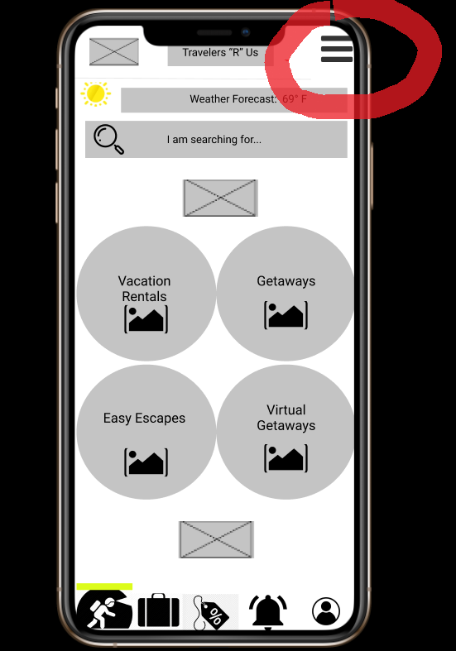

Quotes From Users (Note what users said with regard to the task or a particular issue.)

- “Is the live chat button not supposed to be in the 3 bar thingy?”
- “...oh..I can’t swipe onto another page?”

Presentation Outline
Refer to the template below to create an outline of your presentation. Remember, this is for outlining purposes only, so feel free to switch the order around and add/subtract rows as you see fit.

Your Audience | My team of UX designers, developers, and program manager.
The Story | (Describe how you’ll share the journey of your design process and use it to guide the rest of your outline.)  Our design process has always revolved around user-friendliness and user navigation. User-friendliness and user navigation allow users to enjoy using our product while maintaining easy and accessible control over how they use the product. Keeping this in mind, the rest of the outline of our design process should not over complicate features and just try to allow for more users, no matter their previous experiences of tech, to use this product as easily as possible.
Introduction | (Include topics you want to add to the intro slide of your presentation.)  - User-friendliness  - User navigation  - Making the product more accessible to people and throughout a widespan of devices
Background Information | (Include topics you want to add to the intro slide of your presentation.)  - The purpose of the test was to ensure if the user can efficiently navigate through my mobile app to access the live chat feature in the account page while also testing the ease of navigation.  - My test group consisted of 5 participants  - Area of Focus: Accessibility  - More strategical placement of buttons and features (integrating the live chat feature in the 3 bars icon vector would help)
Findings and Analysis | (Summarize information from your test report in a compelling way; include visuals if applicable.)  - The majority of my users were able to access the live chat feature within a few seconds.  - The majority of my users had to tap on other unnecessary buttons before being able to find the live chat button.  - The 5 icon pictures on the bottom of my app are misdirecting in the sense that users had to play around before finding the live chat button.  - 3/5 of my users kept pressing the 3 bars icon vector.
Conclusion and Q&A | - Maintain the general layout of the page throughout the rest of the app so users can expect to see the main components of each page before advancing to the next page  - Implementing the live chat feature in the 3 bars icon vector
Appendix (Optional) | (If available, include links to your test plan and report.)

Quality Checks
Congratulations! You’ve just completed your prototyping and usability testing project. Now it’s time to give your project deliverables a thorough review before sharing them with your mentor and/or peers. Review the bullets below to ensure that your deliverables meet basic expectations.

Deliverable 1: Usability Test Plan

Meeting Expectations
- The test plan contains a complete set of information, such as description, goals, schedule and environment, equipment used, recruiting method, user information, a link to prototype, and a complete test script.
- The usability test script includes clear scenario(s) and task(s).
- One round of usability testing with 3–5 participants is complete.

Deliverable 2: Usability Test Report

Meeting Expectations
- The report is properly focused in scope and backed by the usability tests conducted.
- The report includes a key insight, score, success rate, descriptions of findings, analysis, and recommendations for each issue.

Deliverable 3: Presentation Outline

Meeting Expectations
- The outline is properly focused in scope and backed by the usability test report.
- The outline includes important background information, test findings, analysis, and clear and actionable next steps.

